Miodrag Prokic

MPInterconsulting
Le Locle - Switzerland
https://www.mpi-ultrasonics.com
October 2021
Clamp-on OD219.1
manual

Ultrasonic World Message

1. Our ultrasonic power supplies are compatible or easily modifiable to drive almost any piezoelectric ultrasonic transducer presently used/known in High Power Ultrasonics Industry, operating between 15 and 100 kHz (or wider) (of course, modifications in critical and demanding cases should be made in our labs). The same generator can operate on any frequency between 15 and 100 KHz (digital software settings, easy frequency selection in any range, and easy frequency window selection in any range).
2. We have the largest and modifiable frequency-window controls (almost any frequency interval, compared to 1 until 2 kHz from competition).
3. Our ultrasonic power supplies are using advantages of dynamic load power regulation between series and parallel resonance (capturing even wider frequency intervals). We can operate any piezoelectric, ultrasonic transducer in its resonant, fixed frequency regimes, in any numerically selected operating frequency interval, and in many forced, arbitrary frequency-modulated wideband regimes. Our generators are much better in many aspects when compared to the well-known ultrasonic generators from others. Our generators can be used on the same way as any other ultrasonic generator, and on many other unique ways. All presently known industrial and manual control options are available (manual, LCD front panel settings and controls, analog, PLC… Everything can be arranged as any other producer (or user) of ultrasonic generators is doing).
4. We implement (safe operating) internal scanning procedure in order to select the optimal operating regime and settings for certain ultrasonic transducer.
5. Our Ultrasonic Power Supplies have smooth power and amplitude regulation. We are applying limitation of maximal load power, maximal transducer amplitude and maximal output voltage on piezoceramics. We are applying overheating, short-circuit, over-current and over-voltage protections.
6. Our standard line of Ultrasonic Power Supplies is operating on European main supply voltage input, being tolerable to input voltages from 200 Vac until 240 Vac, 50/60 Hz. We can easily produce the same Power supplies for other input voltages (115 Vac 50/60 Hz). Internally, all of our standard Ultrasonic Power Supplies have stabilized, universal voltage SMPS for control and logic modules operating from 95 to 265 Vac. We can also (optionally) apply high power PFC input for customized Power Supplies.

Introduction

Please read these operating instructions carefully and follow them before installing or commissioning your product. Failure to observe these instructions can present a risk to life.
Units may be operated by trained personnel only. Failure to comply with this will result in a loss of warranty rights. The device may only be operated and maintained by personnel who have read and understood this operating manual and are familiar with the applicable legal regulations for accident prevention and workplace safety.
Assembly

In addition, ambient temperatures of over 30°C should be avoided. Choose a suitable location that will protect the device from moisture, water, excessive sunlight and heat.
ATTENTION:
• Choose a location that will prevent steam or any other aggressive vapors from penetrating the device.
• Over a period of time, chemically contaminated ambient air can lead to the device being irreparably damaged.

Power supply
The ultrasonic generator draws its power (230 V / 50 / 60 Hz) via the connection cable.
It has an internal main fuse (10 AF).
If you need to change the fuses, unscrew the top of the housing.

ATTENTION:
• For safety reasons, always disconnect the unit from the mains before changing fuses.
• Plug racks into earthed sockets only.
• Always replace blown fuses with new fuses of the same type.
• This should only be performed by qualified, skilled personnel.

Connections on the back of the generator
Output of the HF voltage (possible to have different high voltage connectors)

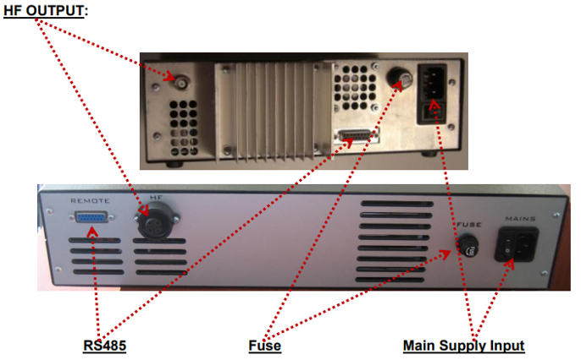

ATTENTION:
• Only use cables specified by the manufacturer.
• Use only shielded transducer connection cables.
• Connect the shielding to the PE conductor on the generator side.
• Only use cables with sufficient cross-section.
• Minimum wires cross-section: 1.5 mm2

AMMM Generator – 3000W

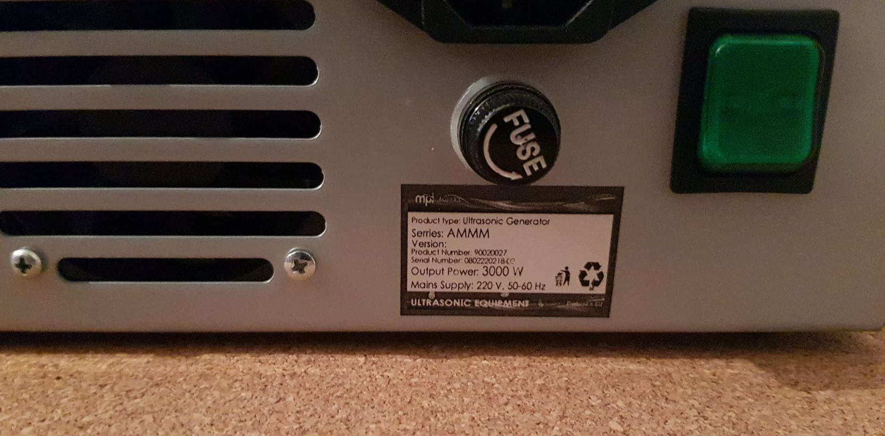

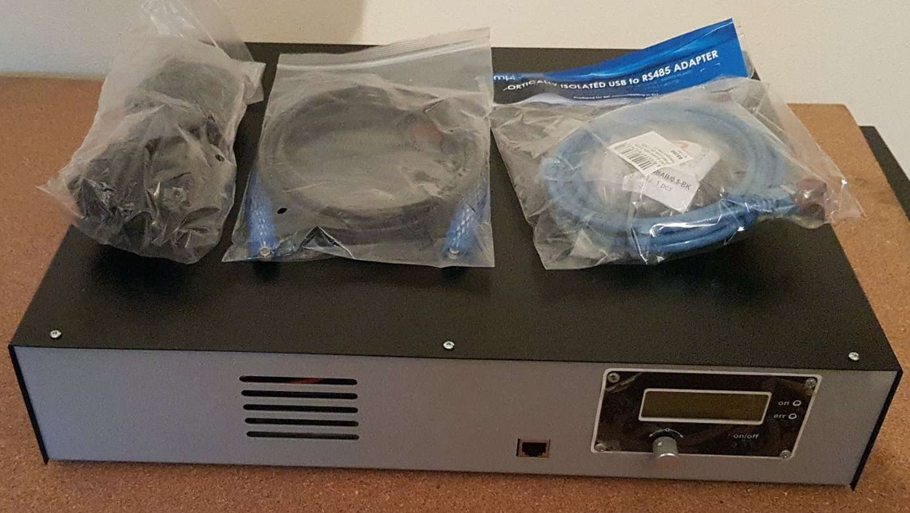

The LCD

Initial screen:  Start Up screen is shown after powering the generator. | 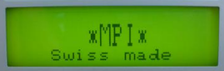
Sweeping (=) SW (=) Periodical, harmonic frequency sweeping:  Here, the encoder can be used to adjust the depth of linear, harmonic and periodic sweeping (around optimal operating frequency). It is adjustable from 0 to 1 kHz. This periodical frequency modulation is evenly distributing ultrasonic activity and minimizing influence of standing waves. | 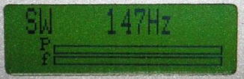
Amplitude:  Display shows the set value of output power and its performance on "A" bar. From 0% to 100% of nominal generator power. During initial testing of new sonotrodes, set the amplitude to some low value (example: 5% to 10%). The numeric operating -power value is not shown on the LCD, but on the menu "Amplitude", it is possible to see the selected value for amplitude (xxx %), and on the bottom of the same LCD it is the bar -graph showing instantaneous amplitude, like on an analog indicator. The exact operating -power is visible on generator LabView software, and it is also accessible through RS485 communication. | 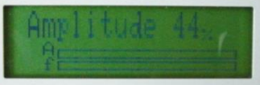
Start Frequency:  Here encoder can be used to set the initial operating frequency (which is between f -s and f -p, but closer to f -p). Here, the encoder can be used to adjust the starting frequency. Start frequency f - start can be changed/adjusted also during the generator operation. The generator has an automatic “frequency tuning” inside the frequency capture range (see the explanation which follows). The frequency capture range can be set by “Span” parameter from 0 to 1 kHz (below the start frequency, towards lower frequencies: f -capture = f -start - Span). The operating resonant frequency of ultrasonic system must be found in advance (before operating the system full -power), performing initial low power scan -testing with the generator Lab View software. This frequency will 20 be found somewhere below the frequency where scanned generator current is maximal, and where the scanned phase function is smoothly rising from its minimal value towards its maximum, when in the same time, the frequency is going towards lower frequencies). The frequency area which is covered (by this type of regulation) depends on the device type (it is impedance-characteristic dependent: f-capture = f-start - Span). | 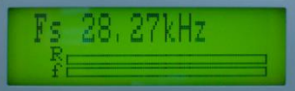
Span:  Selected frequency window where AMMM generator is automatically searching for an optimal operating point. | 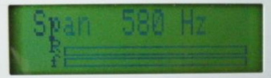
Memory:  After turning the encoder, the display returns to display the volatility and settings for all parameters are stored in memory. Once a setting parameter (for example Fstart) is changed manually, using the front panel encoder (on LCD module), this can also be stored in the internal generator memory by the same LCD module: By selecting the "Memory write" menu, and then it is necessary to turn the encoder clockwise for one step; - The "Memory write" menu will disappear, and we will see the next menu "Fs" (meaning, memorizing is executed). This way, new parameters are written in the internal memory of generator. | 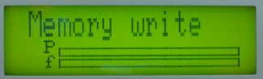

Bar Graph symbols meaning

A (=) actual amplitude; f (=) actual phase value - it depends on working conditions and on what is selected from the adjustments menu;
R (=) actual value of the frequency regulator, inside the span window - when it is not totally filled or total empty - the generator works (regulates) properly. Best is to be somewhere in the middle
When a PC (trough communication cable and RS485 interface) is connected to the generator, PC automatically starts regulating the generator with higher priority. When a PC is disconnected, it is immediately possible to use regulations on the front panel of the generator.
For safety reasons, when ultrasonic system is started first time, when (any or all of): ultrasonic transducer, booster, sonotrode etc. are unknown, or new, or replaced, set the Amplitude value to certain low value (for instance on 5%). In addition, set sweeping SW to certain average value between 20% and 50 %. Then start low power testing and scanning in order to find the best operating frequency interval.
After all initial settings are made (using a PC and supplied Lab View software), Ultrasonic Generator can be activated, and it will start driving ultrasonic converter by pressing ON/OFF button (which is on the front panel). Do not start the generator until all initial settings are verified and sett to safe (low power and low risk) positions.

Frequency-capture range = Span:
This is the safe-operating, low-power frequency scanning of ultrasonic load (Ultrasonic converter + booster + sonotrode + etc.), where the scanning display would visualize the phase difference versus frequency between a load current and load voltage (red color curve), and input DC generator current (white color curve). Such frequency scanning is realized using the Lab View software supplied with ultrasonic generator). In order to make scanning, personal computer with installed Lab View software should be connected to ultrasonic generator trough RS485 interface.
Initially (first safe-operating, low power frequency scanning) should be selected to cover only the expected operating frequency range of ultrasonic system.
In here-described scanning, frequency is smoothly changing towards lower values, starting from f-start and finalizing scanning at the frequency which is equal to f-start – Span. Span is the frequency interval we select as a frequency-capture range (in Lab View Software).
For instance, if ultrasonic system consists of: 20 kHz ultrasonic converter + 20 kHz booster + 20 kHz sonotrode (where not all of them are exactly tuned to operate on 20 kHz, or to have single operating frequency of 20 kHz), we know that we should expect the resulting, central operating frequency of such system to be somewhere close to 20 kHz, and consequently, we could select the scanning frequency range to be between 20 and 21 kHz (meaning f-start = 21 kHz, and Span = 1 kHz). Of course, another relevant example could be to select such frequency scanning between 19.5 kHz and 20.5 kHz (meaning: f-start = 20.5 kHz, Span = 1 kHz). Later (during scanning), the Lab View software will search and find real, average operating frequency somewhere inside of the area covered by scanning).
When/where generator input DC current (during such scanning) is reaching certain relative maximum (at certain frequency), this is indicating that ultrasonic load is also consuming certain power, and/or increasing its oscillating activity. This is the reason why we are taking such DC current maximum as the (upper) reference point for frequency scanning. In reality, this is also related to impedance curve of ultrasonic system under testing, since empirically we know that central operating frequency of a stable operating regime of ultrasonic system (in AMMM regime, under wideband frequency sweeping) should be below the frequency when the input DC current is reaching its maximum. This is also the reason to select an initial f-start just below the frequency where DC current is reaching maximum, and where the phasedifference function has its minimum (with a tendency to grow towards lower frequencies).
In the next step (next safe-operating frequency scanning) we should select new (shorter) value for Span to cover only the closest part of the phase-curve (red color), which is showing the part of phase-difference curve starting from certain minimal value until its first maximal value (below the frequency where input, DC generator current is maximal). New f-start will be again at the point where the phase curve is minimal.
This way, we will visualize mentioned part of the phase difference curve on a larger display, and we will be able to estimate the frequency which is in the middle of that frequency interval, and which is approximately equal: f-start – 0.5(Span). Later, real AMMM operating frequency regime (under automatic regulation found by internally implemented hardware and software) will find its average or central operating frequency (inside of the new Span interval) and we will be able to perform/set large frequency sweeping around that frequency (in both directions). One of examples showing such experimental frequency Span determination of the most promising AMMM operating zone will be presented later.

AMMM Generators Software

This is National Instruments, Lab View based operating software for controlling and setting our ultrasonic generators. In order to operate such software from a personal computer, it is necessary to install Lab View Run-Time and NI serial ports drivers (before using our ultrasonic generators software). NI software can be downloaded from the web links listed below:
1. Lab View Run-Time Engine 2012 – Windows 10 (64-bit)
Standard download.
https://www.ni.com/pt-pt/support/downloads/drivers/download.ni-visa.html#409839

2. The generator is communicating with Lab View software trough USB to RS485 adapter. Install the latest driver from here:
https://ftdichip.com/drivers/

3. software for our ultrasonic generators is also here:
https://www.mastersonics.com/documents/mmm_basics/mmm_power_supplies/AMMM/ALL-ammm-generators/ammm_generator_with_current_limit-rs485/

Create a Folder. Place inside of the folder the followings files:
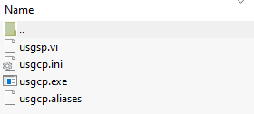

Procedure to Connect Generator to PC

1. Connect ultrasonic generator to a PC using the RS485-USB adapter (supplied with the WELDING generator; -see the picture below). Switch ON the main switch of your WELDING ultrasonic generator (This is only a main supply power input; -for instance 230 Vac, 50/60 Hz. Ultrasonic output power is still not activated). PC will not connect to ultrasonic generator if generator is not powered by main supply input.

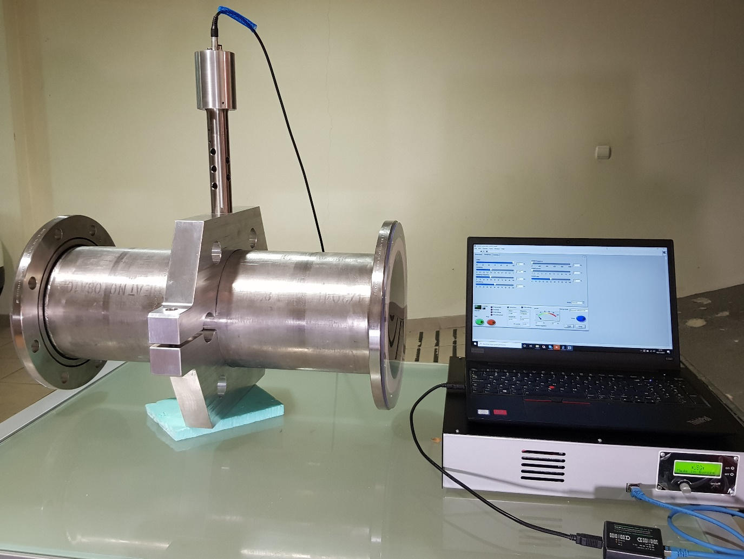
2. Activate RS485-USB connection line between your AMMM generator and your PC (select proper, active serial, COM port, Open Serial port dialog, rescan/refresh if necessary… until LEDs on the RS485-USB box will start blinking):
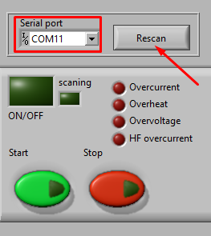

In the lower left corner of the software interface (First TAB) it is necessary to select a free/available COM port and press Rescan - this will activate the connection between the generator and a PC, and the green lamp “Connection” will start blinking (the blinking green light is always a sign, that there is established communication between generator and PC).

3. After activating “usgcp.exe” software you will see the following LabVIEW user interface for controlling AMMM generators (which has 3 software setting TABs):

Followings TABs present the CORRECT SETTINGS to OPERATE the CLAMP-ON OD219.1
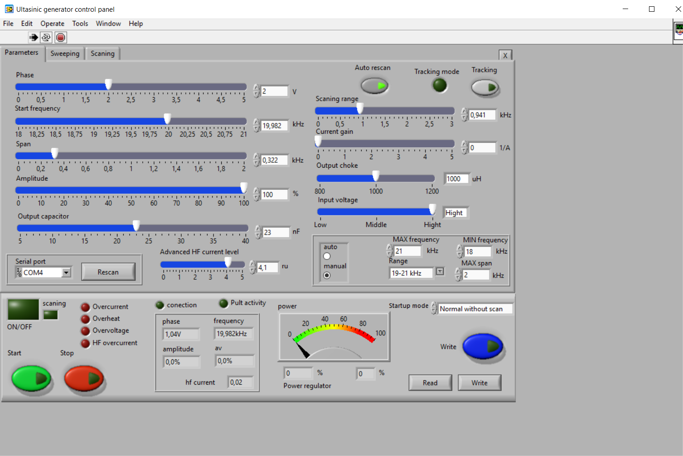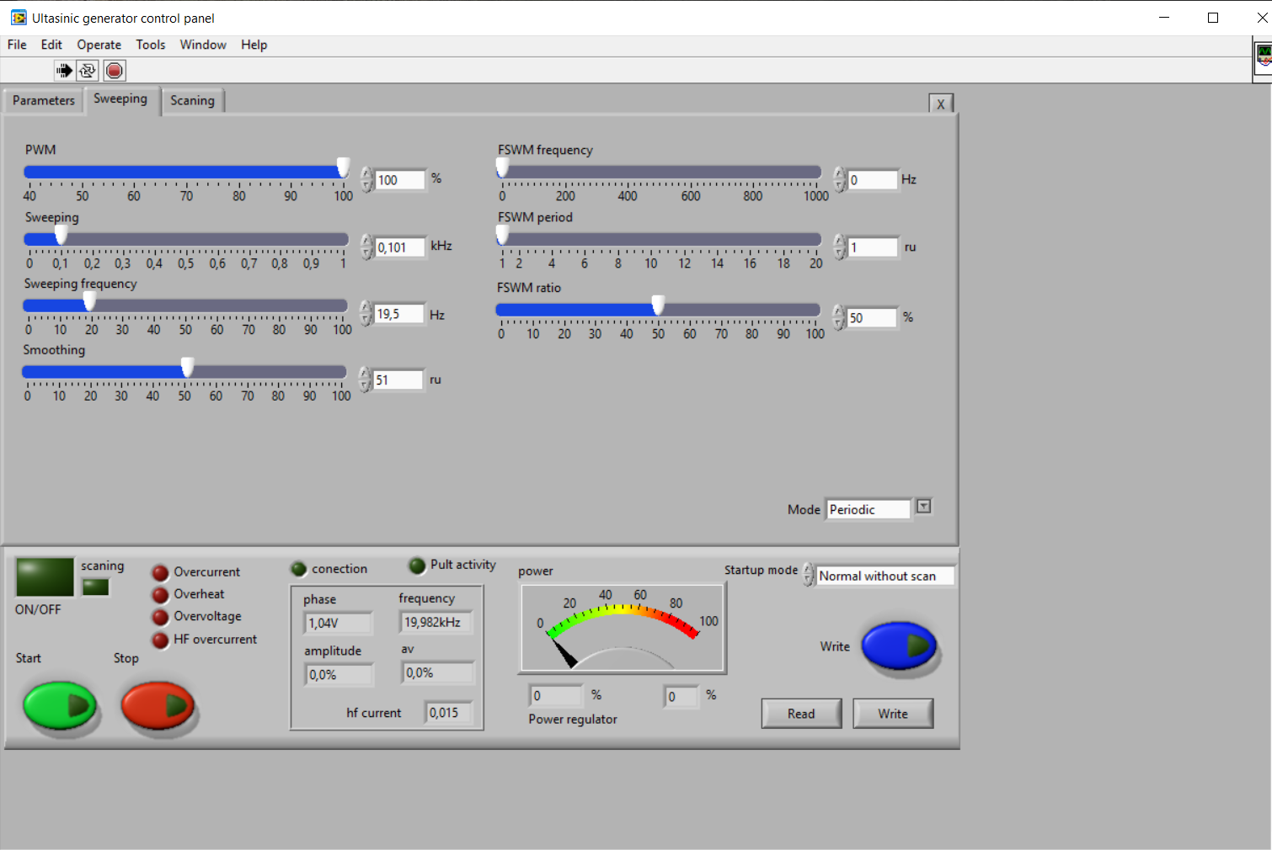
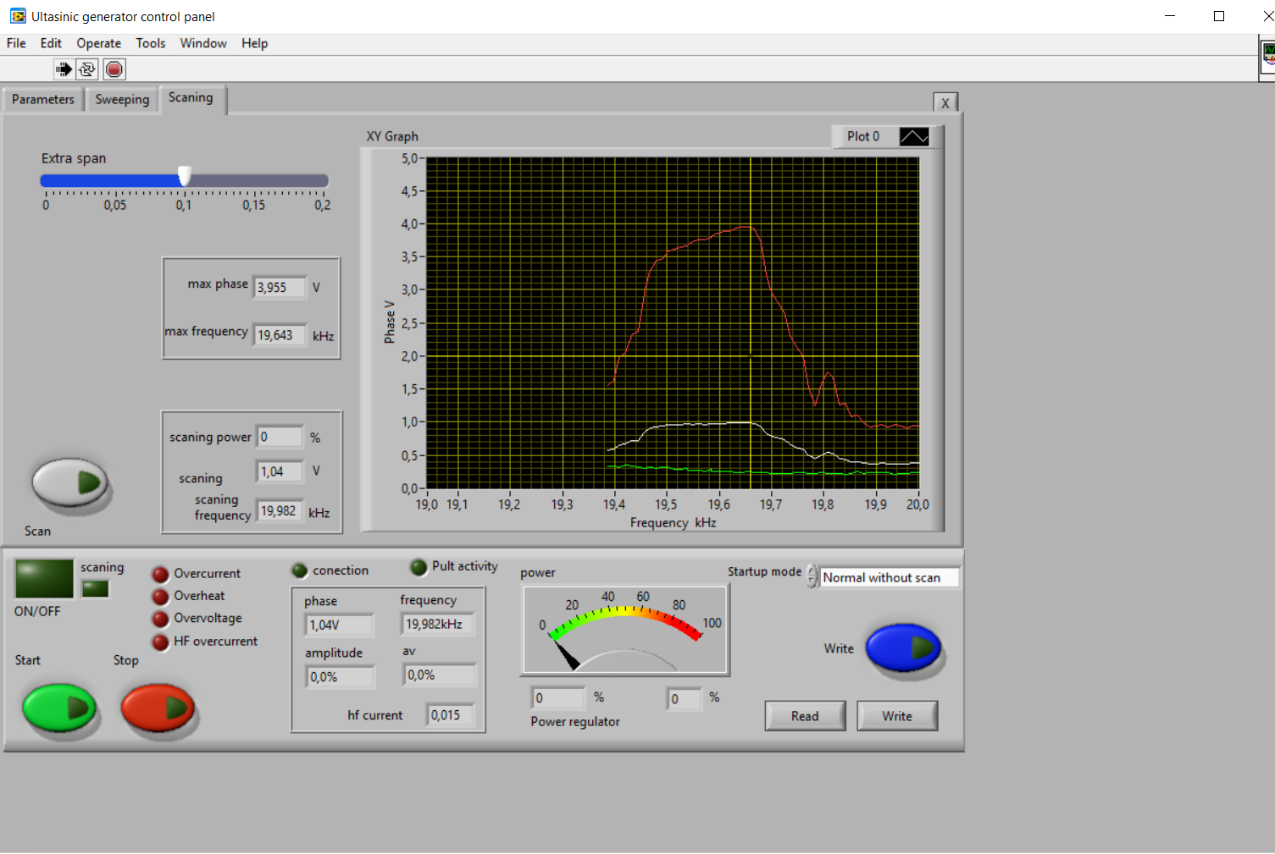

Results of your CLAMP-ON OD219.1 mm
